OC: soil organic carbon, C/N: ratio of carbon to nitrogen; TN: soil total nitrogen; DT: drying days of a drying-rewetting cycle; frequency: total days/the number of drying-rewetting cycles
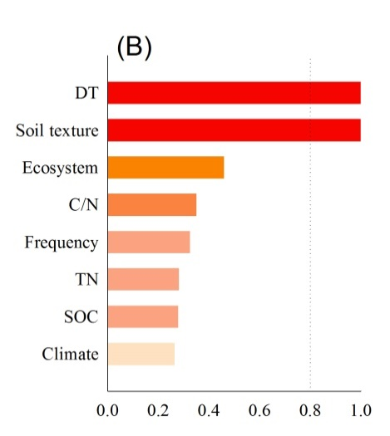
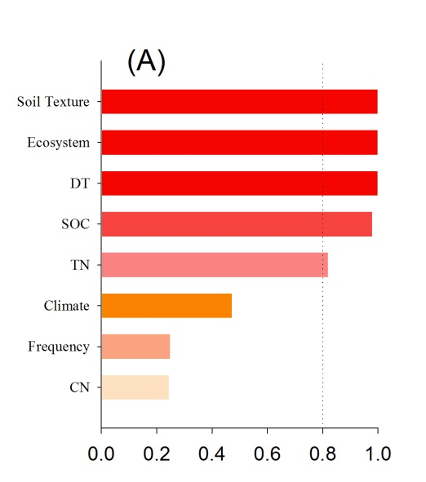

Fig.(A) using the code as follow:
modelselection<- glmulti(yi ~ DT+soiltexture+ecosystem+CNratio+frequency+TN+SOC+climate, data=eff1, level=1, fitfunction=rma.glmulti, crit="aicc", confsetsize=256,plotty=FALSE)
Fig.(B) using the code as follow(calculate the important value one by one):
modelselection<- glmulti(yi ~ DT, data=eff1, level=1, fitfunction=rma.glmulti, crit="aicc", confsetsize=100)
The results of Table.1 were calculated by the code:
# for Categorical variables
r1<-rma(yi,vi, mods=~ecosystem, data=eff1, method="REML")
# for numeric variables
r2<-rma(yi,vi, mods=~SOC,data=eff1, method="REML")
Variables |  | n | Q_{T} | Q_{M} | Q_{E} | P
SOC |  | 125 | 138.30 | 0.25 | 138.05 | -0.614
TN |  | 125 | 138.00 | 0.005 | 137.995 | -0.943
C/N |  | 125 | 139.17 | 1.07 | 138.10 | -0.300
D/T |  | 125 | 191.70 | 45.90 | 145.80 | -0.000
Frequency |  | 125 | 138.59 | 0.10 | 138.49 | 0.747
Soil texture |  | 125 | 142.8 | 6.52 | 136.28 | 0.038
Climate |  | 125 | 138.65 | 0.18 | 138.48 | 0.676
Ecosystem |  | 125 | 141.04 | 4.99 | 136.05 | 0.082
you can see, the results of this table is the same with Fig.(B), but it’s totally different with Fig.(A). If I add Fig.(A) and Table1 into my paper, I can not explain it. If I put Fig(B) and Table 1 into my paper, although it seems better, I don’t think I should do it because I don’t know why

In summary, I want to know why different methods led to inconsistent results.
Table. 1 Relationships between the effect size (RR) and soil variables by meta-regression

